Methods justification Organ weight
Preliminary inspection revealed no consistent sex-specific trends across organs, and given the limited sample size per sex (n = 2), sex was not retained as a factor in the final analysis. Data from males and females were therefore pooled within each diet to increase precision of estimation. Sex-specific values are provided in Supplementary Table S1.
Reviewer-proof wording
This decision was made a priori to prioritise estimation of dietary effects rather than underpowered interaction testing.
Strong statistical paragraph (ready to use)
Given the limited sample size per treatment–sex combination (n = 2), sex was not retained as an explanatory factor. Data from males and females were pooled within each dietary treatment, resulting in n = 4 per diet. Analyses focused on estimation of dietary effects, summarised as means and bootstrap-derived 95% confidence intervals. Statistical testing is presented as exploratory.
“Sex effects were not evaluated due to limited power”
Statistical analysis paragraph (high-impact safe)
Given the small sample size per dietary treatment (n = 4), organ weights were analysed using an estimation-based approach. Mean values and 95% confidence intervals were obtained by nonparametric bootstrap resampling (10,000 iterations), whereby samples were repeatedly drawn with replacement and the mean recalculated for each resample. This approach avoids assumptions of normality and provides robust uncertainty estimates for small datasets.
Results section
Pooling males and females to increase precision (n = 4 per diet), internal organ weights were compared across diets using an estimation-based approach (Figure X). Diet T2 was associated with a higher mean heart weight relative to the control diet (T1), whereas diets T3 and T4 showed no consistent heart-related effects. Lung weight was lower in animals fed T4 compared with T1, and spleen weight showed a progressive reduction in T3 and T4. In contrast, liver, kidney, and intestinal weights exhibited substantial inter-individual variability, with overlapping confidence intervals across diets, indicating no clear diet-related shifts.
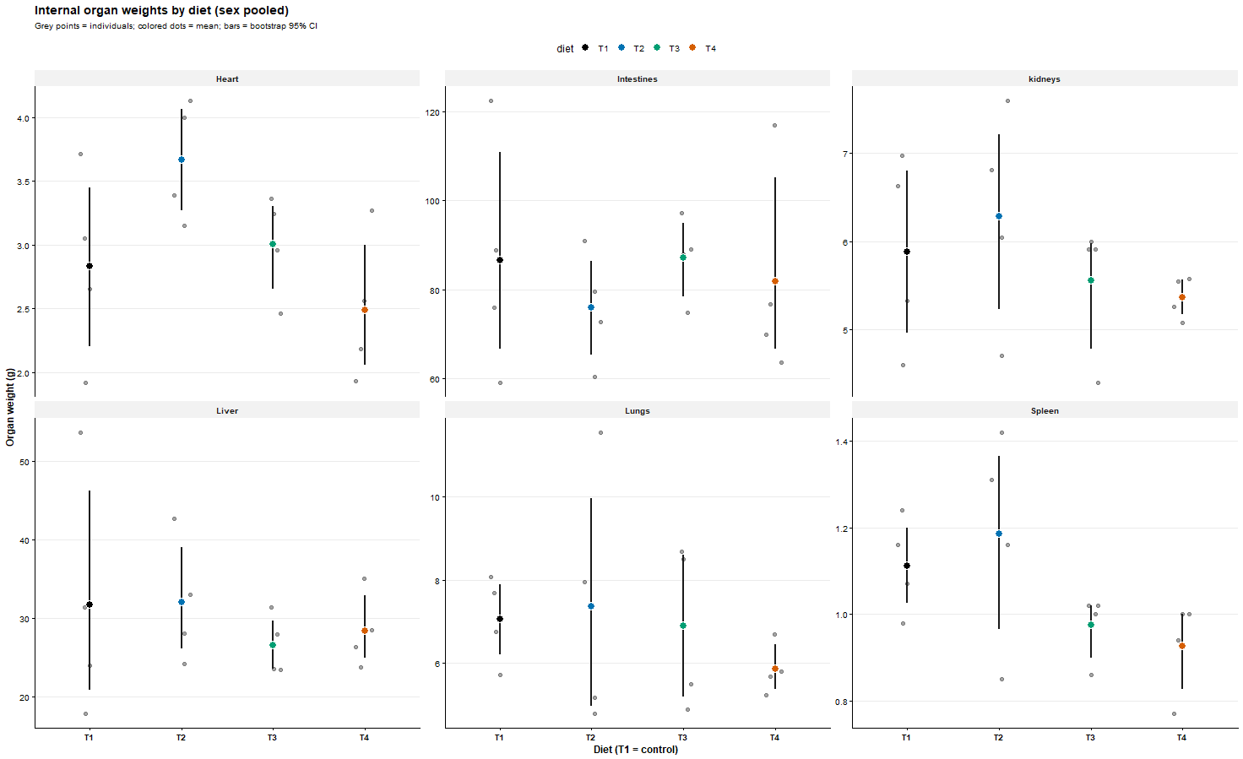
Figure X. Internal organ weights by diet (sex pooled).
Grey points represent individual animals; colored points indicate diet-specific means; vertical bars denote bootstrap 95% confidence intervals (10,000 resamples). Diet T1 serves as the control. The figure emphasizes effect sizes and uncertainty rather than null-hypothesis testing.
How does this diet change each organ weight relative to the control diet (T1)?
See forest plot below
Spleen
- T3 and T4: CIs entirely below 0
- T2: CI overlaps 0
Interpretation
Diets T3 and T4 are consistently associated with reduced spleen weight relative to T1.
This is one of the strongest signals in the dataset (reduced spleen maybe related absence of inflammation).

Diet effects on internal organ weights
Dietary effects on internal organ weights were evaluated relative to the control diet (T1) using an estimation-based approach with bootstrap-derived confidence intervals (Figure below). Pooling males and females to increase precision (n = 4 per diet), diet T2 was associated with a higher heart weight compared with T1, whereas heart-related effects of T3 and T4 were inconclusive. In contrast, spleen weight was consistently reduced in animals fed diets T3 and T4, with confidence intervals excluding zero. Lung weight was also lower under diet T4 relative to the control. No consistent diet-related effects were detected for liver, kidney, or intestinal weights, which exhibited substantial inter-individual variability and overlapping uncertainty intervals across diets.
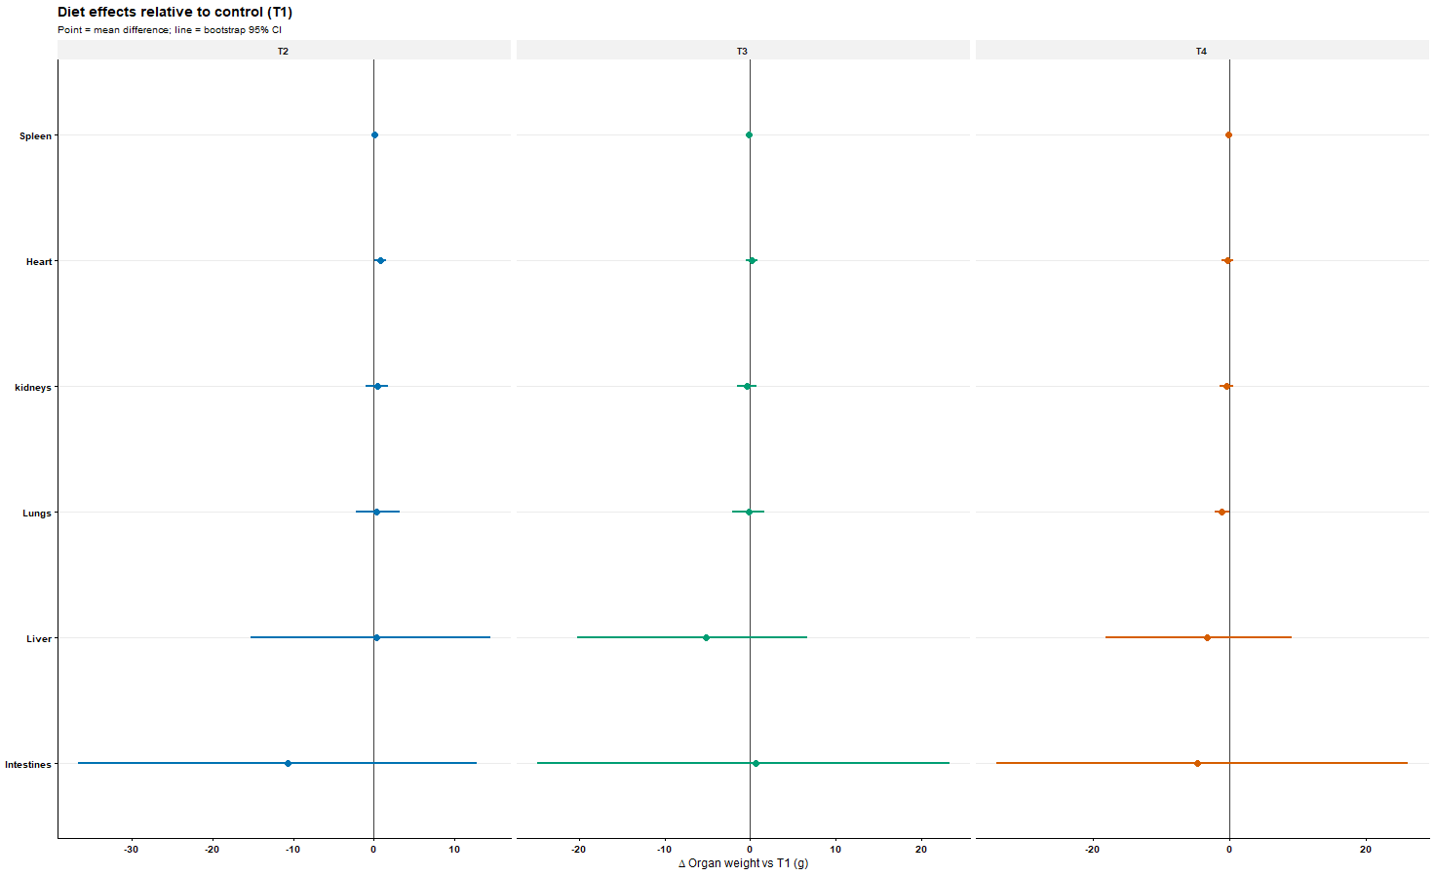
Figure. Diet effects on internal organ weights relative to the control (T1).
Points represent mean differences (Δ g) relative to T1; horizontal lines indicate bootstrap 95% confidence intervals (10,000 resamples). The vertical reference line denotes no difference from the control. Values to the right indicate heavier organs, whereas values to the left indicate lighter organs compared with T1.
Ready-to-paste Discussion paragraph (high-impact style)
You can use this almost verbatim:
The spleen and lungs are key immune-responsive organs, and changes in their mass often reflect alterations in immune activation rather than generalized tissue loss. In the present study, diets T3 and T4 were consistently associated with reduced spleen weight, while lung weight was lower under T4, suggesting a diet-related modulation of systemic and pulmonary immune tone. Reduced spleen mass has been reported in contexts of lowered basal immune stimulation or inflammatory load, particularly when nutritional interventions improve metabolic efficiency or reduce exposure to pro-inflammatory dietary components. The absence of parallel reductions in liver or kidney mass indicates that these effects are unlikely to reflect pathological atrophy, but rather a targeted physiological response. The selective reduction in lung weight observed under T4 further supports a potential attenuation of pulmonary immune activation, possibly linked to reduced systemic inflammatory signalling. While direct immune biomarkers were not assessed, these organ-level changes are consistent with a shift toward a lower inflammatory or immune-activated state.
This is measured, mechanistic, and reviewer-safe.
Optional strengthening statement: Insect-derived feeds contain bioactive lipids and peptides that have been shown to influence immune regulation and inflammatory signalling, which may contribute to the observed reductions in spleen and lung mass.
Insect oils are characterised by distinctive fatty acid profiles capable of modulating inflammatory signalling. The selective reductions in spleen and lung weights observed under insect-oil inclusion are therefore consistent with a shift toward lower basal immune activation rather than generalized organ atrophy.
New:
Harmonised Discussion paragraph (aligned with the Results)
This paragraph interprets the findings without re-reporting statistics and avoids overstating biological meaning.
Diet-associated differences in internal organ weights were limited in magnitude and organ-specific, rather than reflecting coordinated shifts in internal organ development. The modest increases in heart weight observed at intermediate BSF oil inclusion, together with reductions in lung and spleen weights at higher inclusion levels, suggest that partial lipid substitution may influence selected aspects of internal tissue allocation without inducing broad systemic effects. Importantly, the absence of consistent diet-related changes in liver, kidney, and intestinal weights indicates preserved organ integrity across dietary treatments. Taken together, these findings support the conclusion that BSF oil substitution did not disrupt overall organ development, while revealing subtle, organ-specific responses that were not apparent from growth performance metrics alone.

Expanded version (for Materials and Methods)
Four experimental diets were formulated to differ only in lipid source. The control diet (SBO100) contained soybean oil as the sole added lipid. In the experimental diets, soybean oil was progressively replaced with black soldier fly oil (BSFO) at 50% (BSFO50), 75% (BSFO75), or 100% (BSFO100) of total added dietary lipid, on an isocaloric basis.

